Assignment:3.2

Task:1

Gemini explanation:

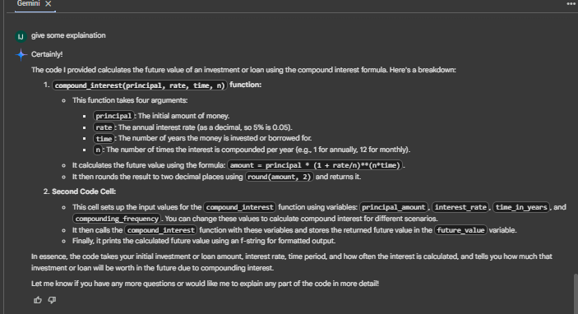

Input and output:

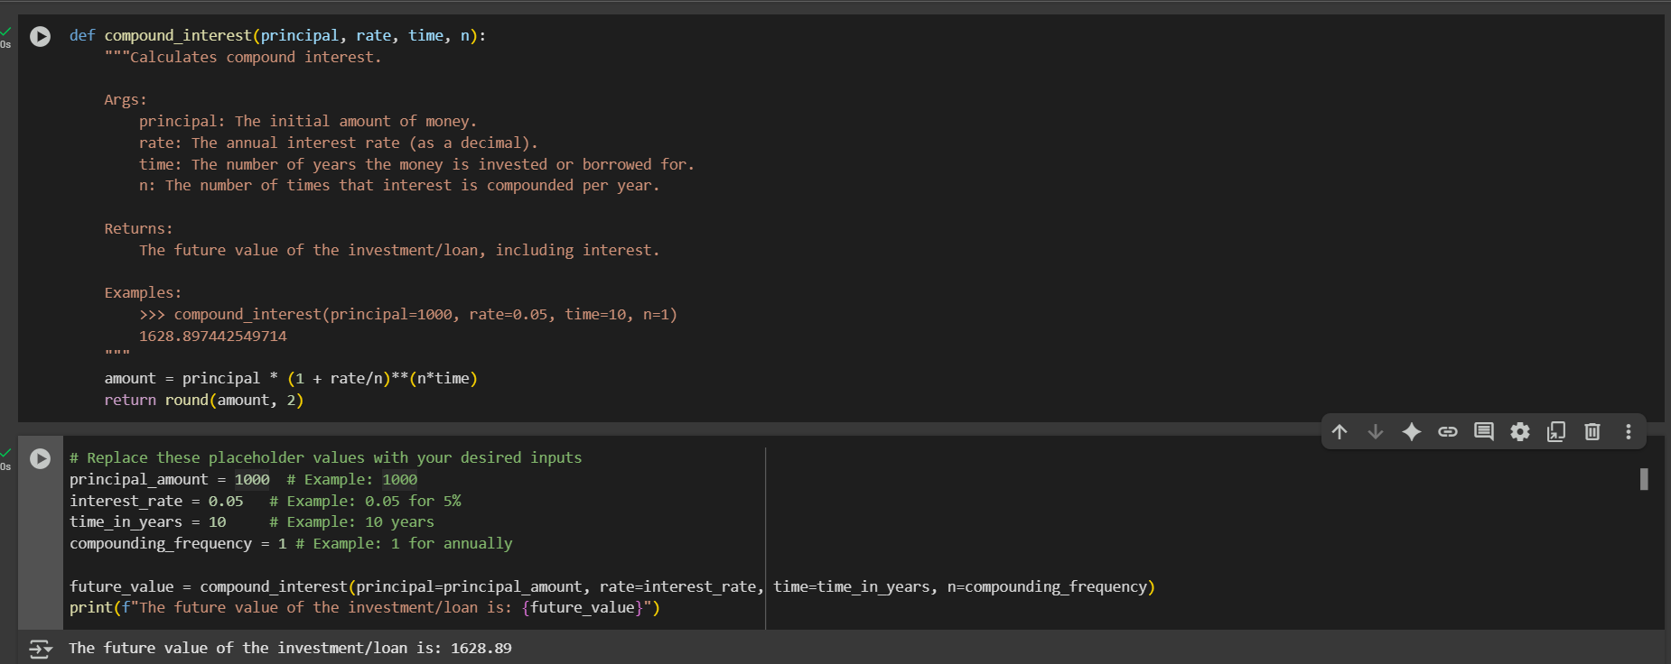

Task:2

Gemini explanation:

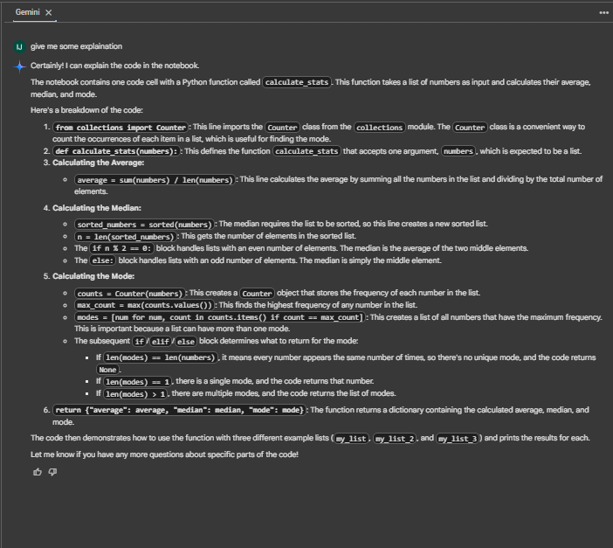

Input:

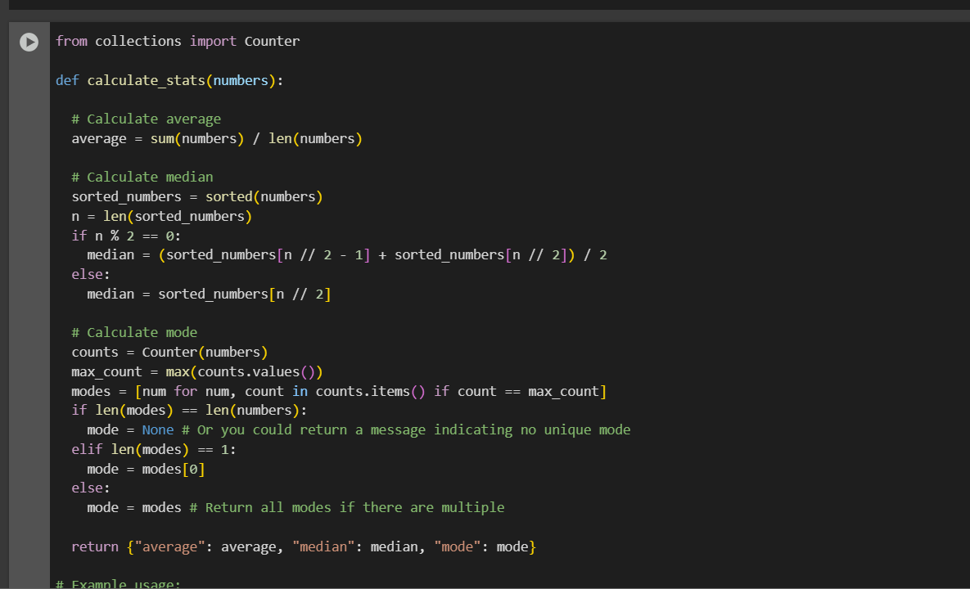

Input &output:

Task :3

Gemini explanation:

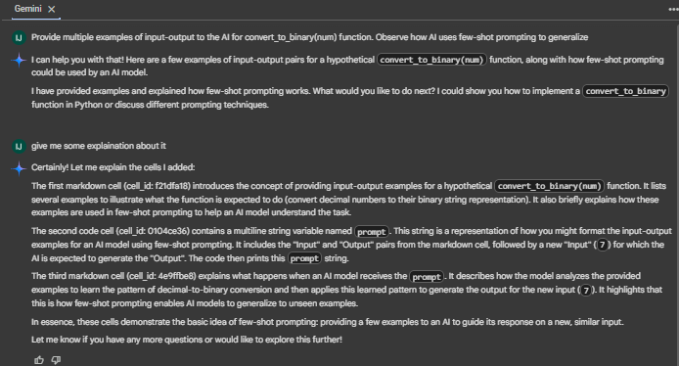

Input:

Output:

Task:4

Gemini Explanation:

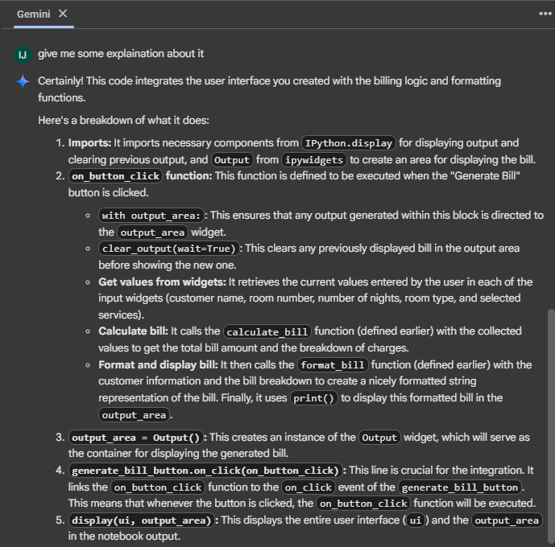

Input:

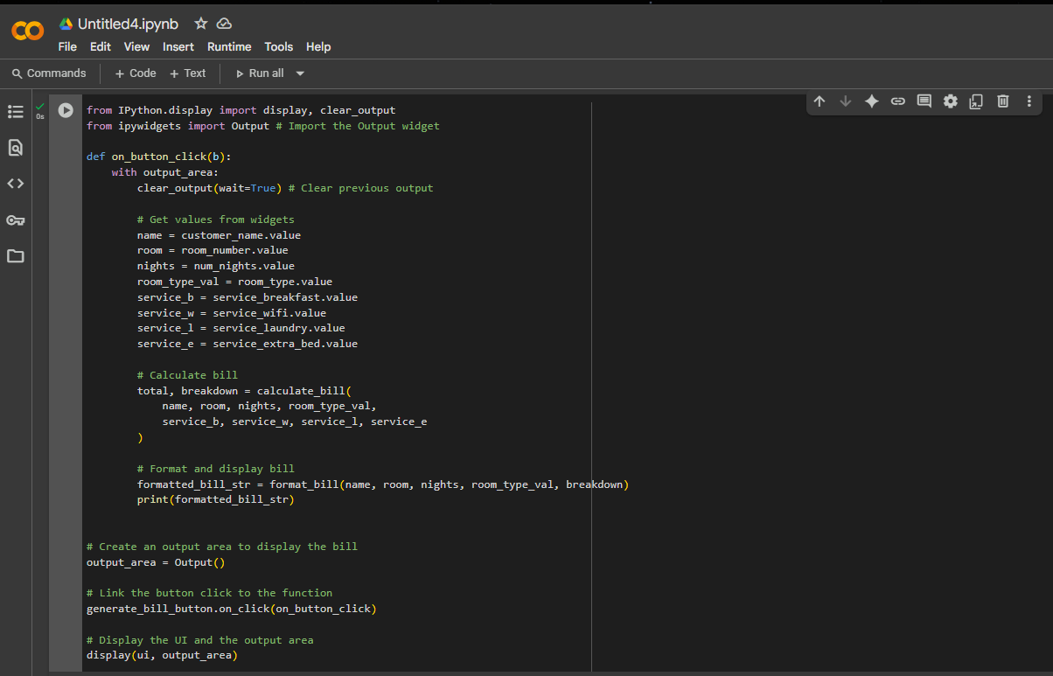

Output:

Task:5

Gemini explanation:

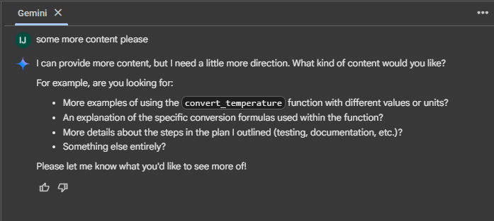

Input:

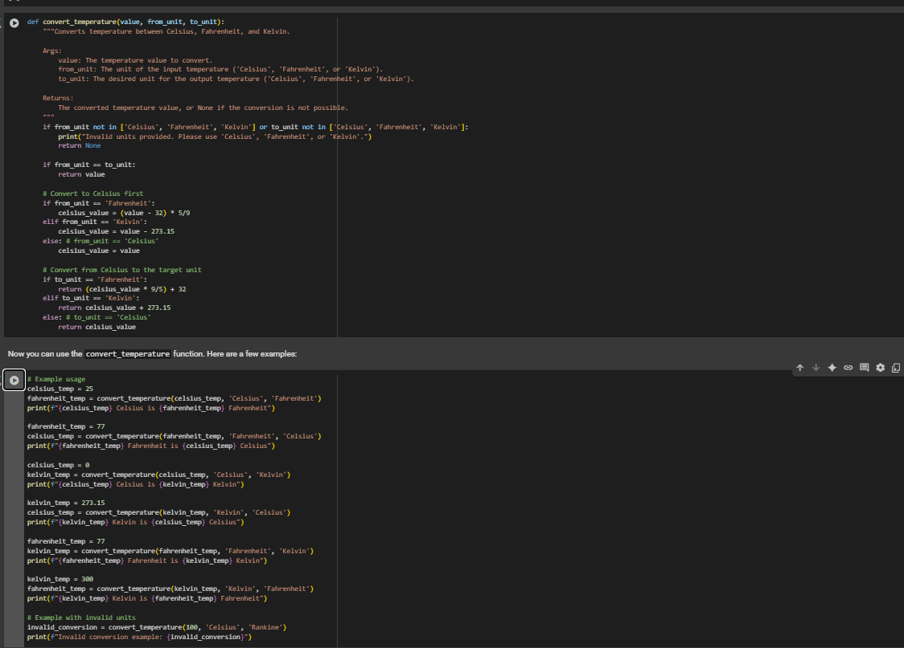

Output:

